**MODEL LAB EXAMINATION**

**CSA1140 – OBJECT ORIENTED ANALYSIS AND DESIGN FOR PROJECT**

**Name :- U. Abhilash Date:- 15/09/2022**

**Reg no:- 192011262 Slot : Slot A**

**ONLINE VOTING SYSTEM**

**1.Use case diagram :-**

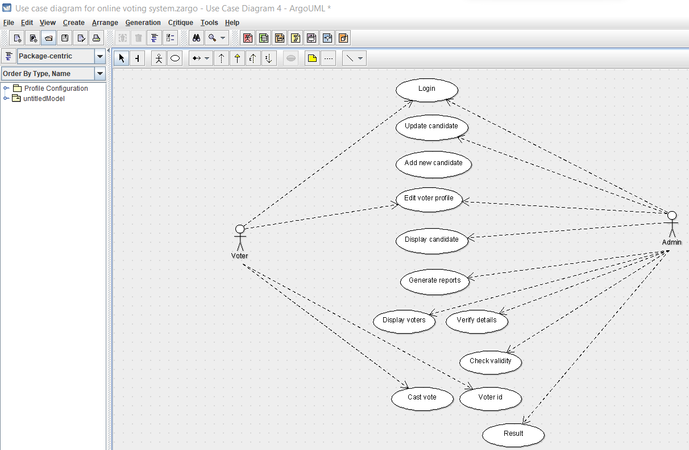

**2. Class diagram:-**

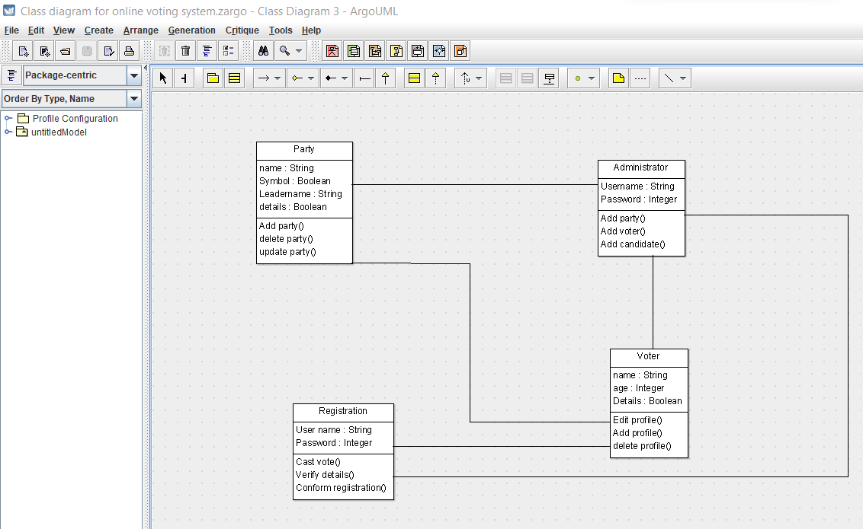

**Code:-**

import java.util.Vector;

public class Voter {

public String name;

public Integer age;

public Boolean Details;

public Vector myParty;

public Vector myAdministrator;

public Vector myRegistration;

public void Edit profile() {

}

public void Add profile() {

}

public void delete profile() {

}

}

**3. Activity diagram:-**

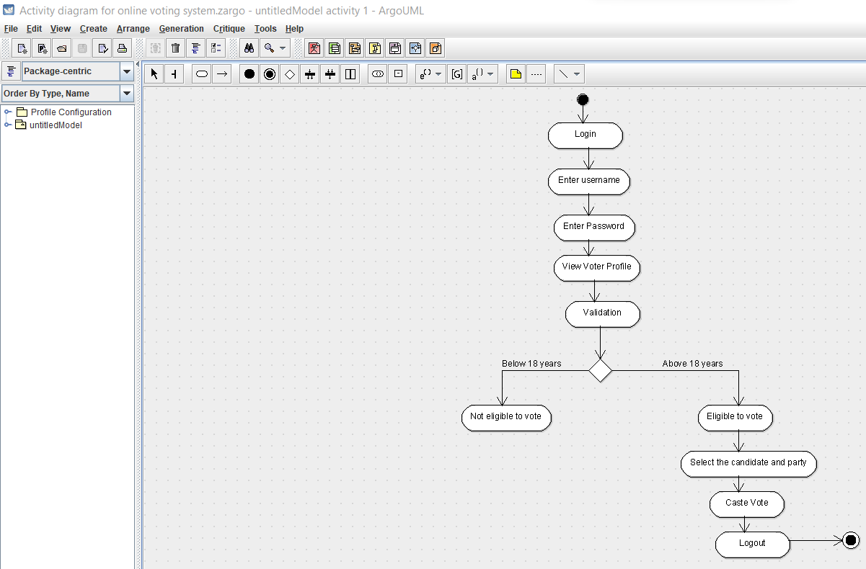

**4. Sequence diagram :-**

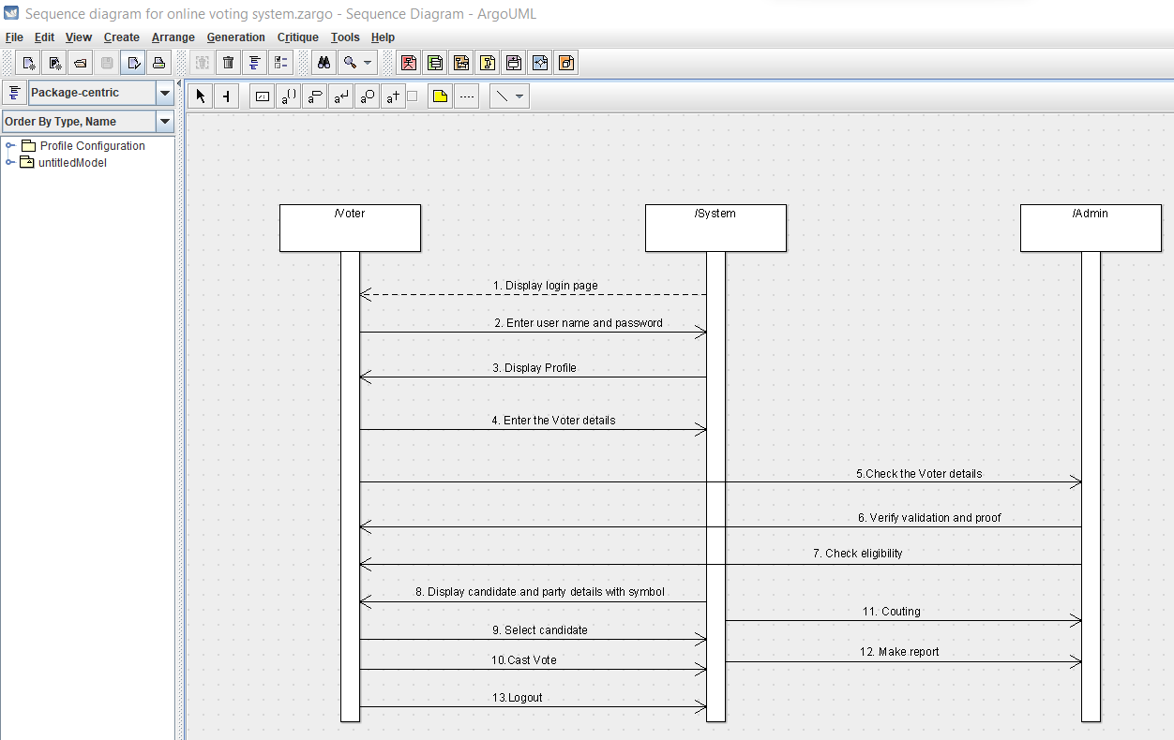

**5. Collaboration diagram :-**

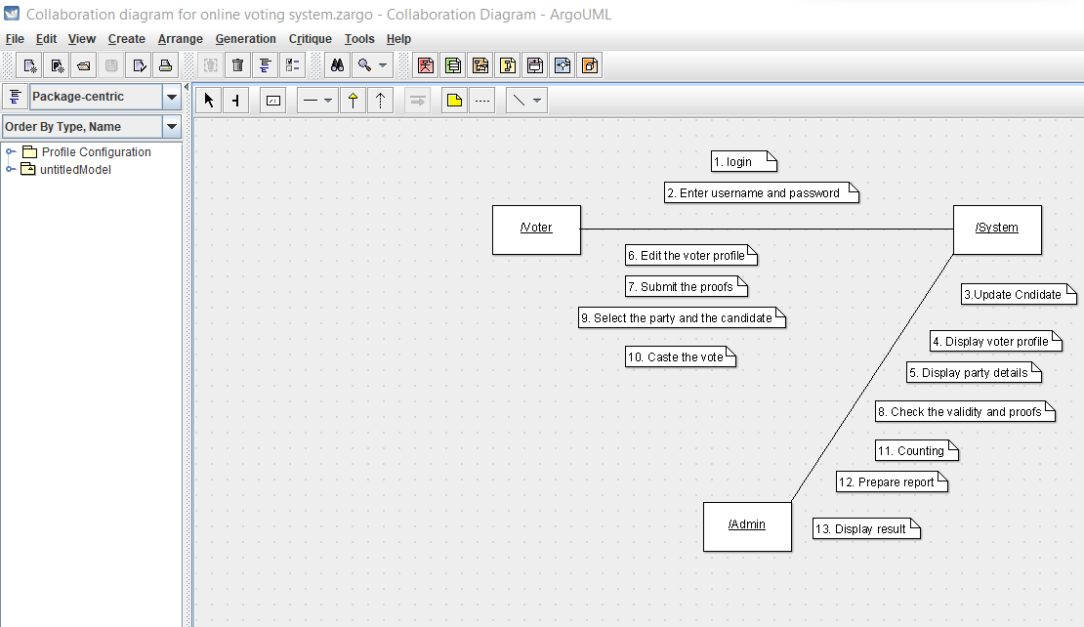

**6. State chart diagram:-**

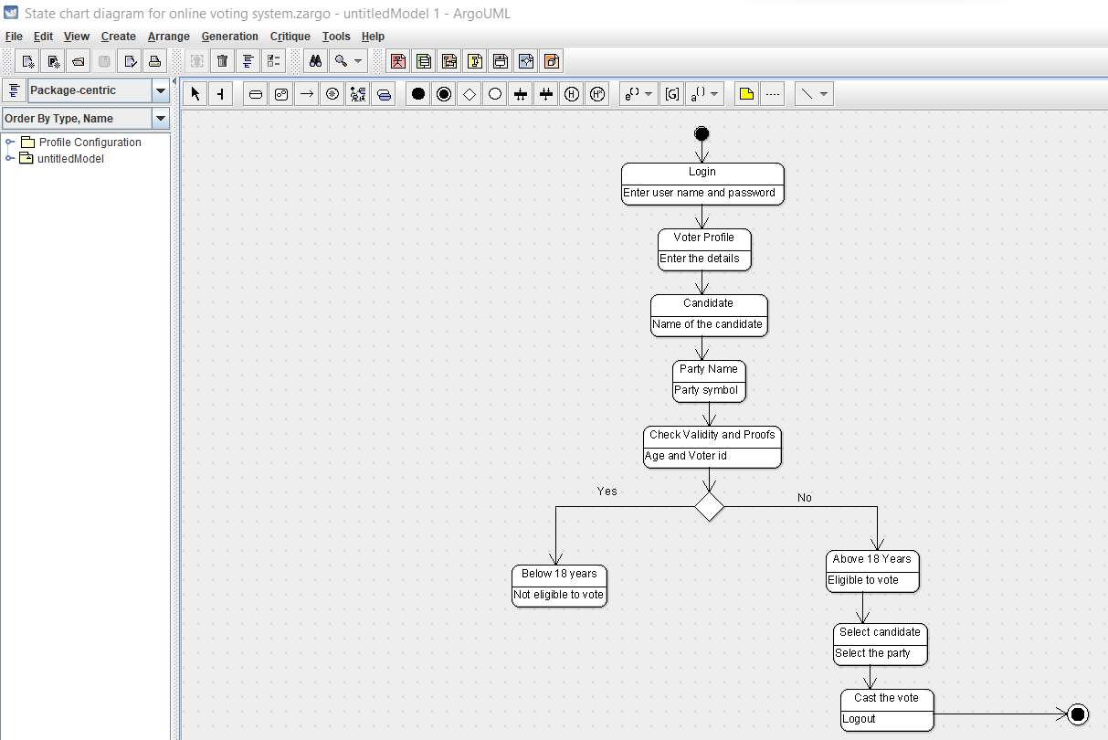

**7. Component diagram :-**

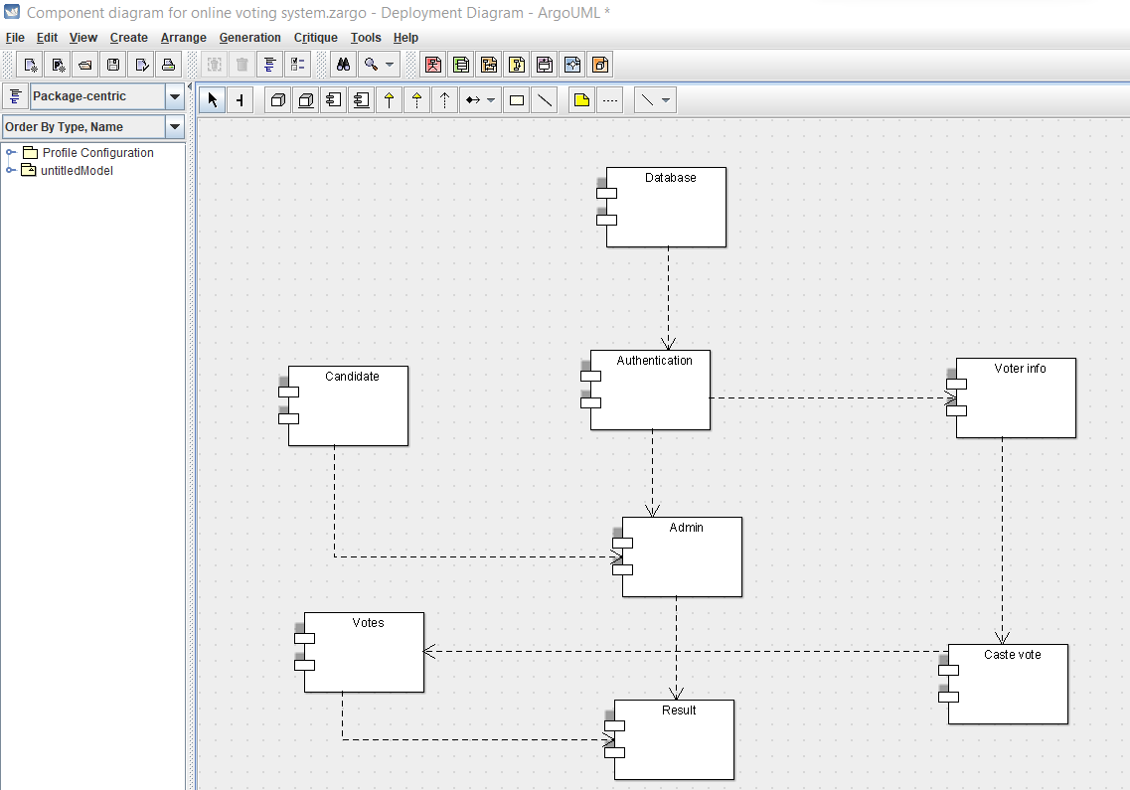

**8. Deployment diagram :-**

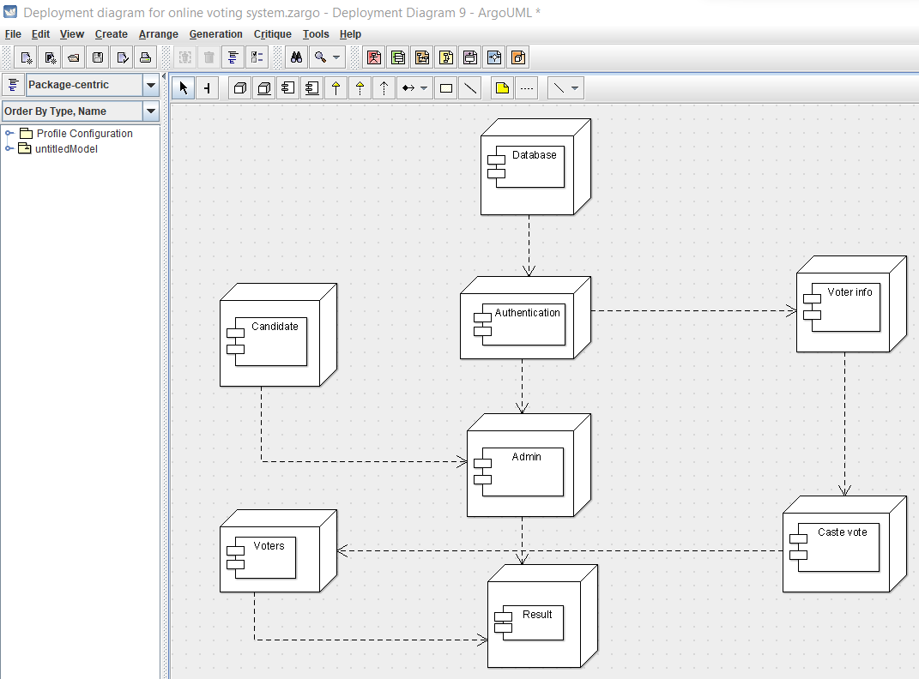

**9. Package diagram :-**

